*A Minor**Project Report On*

“Travelista{ Tour &Travelling }”

For the Partial Fulfilment of the 5th Semester Practical of Bachelor of Computer Application of Veer Narmad South Gujarat University, Surat

Bachelor of Computer Application [B.C.A] Semester – V

By

*Gaurav Kumath* Exam No:- 207000110144

Guided By

*[Prof. Swati Khandelwal]*

DEVIBA INSTITUTE OF COMPUTER APPLICATON, SABARGAM Year: 2024-2025

|  |  |
| --- | --- |
|  | **AMBABA COMMERCE COLLEGE,MANIBA INSTITUTE OF BUSINESS MANAGEMENT & DEVIBA INSTITUTE OF COMPUTER APPLICATION,**  **SABARGAM (Self Finance)**  **At. Sabargam, Po.Niyol, Tal. Choryasi, Surat-394 325.**  Managed By Shree Dakshin Gujarat Shikshan Samaj, Kumbharia |

Certificate

This is to certify that GAURAV KUMATH Roll no **266** Exam Seat Number: __2986_____have/has satisfactorily presented their Project workEntitled **“Tour & Travelling”** as a partial fulfillment of requirements for **5th *Semester– B.C.A.,*** during the academic Year 2024-2025.

**Guide Name: Prof.Swait Kandelwal**

**Dr. Falguni M Thakkar**

**Principal**

**Ambaba Commerce College, MIBM & Deviba Institute of Computer Aplication, Sabargam**

**Date :**

**Place : Sabargam, Surat**

Acknowledgement

This report has been prepared for the partial fulfilment of the requirements for the degree of Bachelor of Computer Application. This is a Minor project assigned to us during us academic study in BCA fifth semester, we should remain thankful to many people for the successful completion of this project.

we would like to express sincere gratitude to our project guide, **Pro. Swati khandelwal**, for providing necessary guidelines for completion of this report. We are thankful to him for his continuous reinforcement and motivation for completing the project successfully. We thank for his regular feedback and suggestion to improve the report further. We are very thankful to all respected teachers and staff of the Department of Bachelor of Computer Application for helping, cooperation and encouraging us in every aspect of us academic study. Also, we would like to thank all the respondents who filled the questionnaire and helped us with the continuation of the project. Finally, we would like to thank my friends for uplifting my spirit to complete the report in time.

|  |  |  |
| --- | --- | --- |
| **INDEX** | | |
| **Chapter**  **No** | **Description** | **Page no** |
| **1** | **Introduction** | **1** |
|  | 1.1 Existing System | **2** |
|  | 1.2 Limitation of Existing System | **4** |
|  | 1.3 Proposed System Introduction | **5-6** |
|  | 1.4 Project Profile | **7-9** |
|  | 1.5 Scope of Proposed System | **10-11** |
|  | 1.6 Objective of Proposed System | **12-14** |
|  | 1.7 System Environment Description | **15** |
|  |  | **-** |
| **2** | **Detail Description of Technology Used** | **16** |
|  | **1.FrontEnd Technology** | **-** |
|  | 1.1 ReactJS | **-** |
|  | 1.2 Java Script | **-** |
|  | 1.3 Bootstrap and CSS | **-** |
|  | 1.4 HTML | **-** |
|  | 2.BackEnd Technology | **17** |
|  | 2.1 MySQL | **-** |
|  | 2.2 MongoDB | **-** |
| **3** | **System Design** | **18-22** |
|  | 3.1 Task Dependency Diagram | **23** |
|  | 3.2 Data Flow Diagram(DFD)/UML | **24** |
|  | 3.3 Database and table | **29** |
| **4** | **User Interface** | **32** |
|  | 4.1 Admin Side | **32** |
|  | 4.1.1 Admin Login | **32** |
|  | 4.1.2 Admin Dashboard | **32** |
|  | 4.1.3 Admin Booking Details | **.** |
|  | 4.1.4 Admin Signup Details | **.** |
|  | 5.2 Client Side | **.** |
|  | 5.1.1 Client Login | **33** |
|  | 5.1.2 Client Registration | **33** |
|  | 5.1.3 Clinet tour | **34** |
|  | 5.1.4Client home | **34** |
|  | 5.1.5 Client Booking | **35** |
|  | 5.1.5 Contact us | **35** |
|  |  | **.** |
|  |  | **.** |
|  |  | **.** |
| **5** | **Conclusion** | **36** |
|  |  |  |
| **6** | **Bibliography** | **37** |
|  |  | **.** |
|  |  | **.** |

# Welcome to Travelistra:INTRODUCTION

"Welcome to **Travelista**, where your journey begins with endless possibilities. Discover a world of exciting destinations, personalized travel experiences, and seamless bookings. Whether you're planning a weekend getaway or a global adventure, **Travelista** is here to make your travel dreams come true."

###### Explore with Travelista:

"At **Travelista**, we believe travel should be inspiring and effortless. Our platform offers a wide range of destinations and experiences tailored to your preferences. From finding the perfect getaway to booking your next adventure, **Travelista** is your gateway to exploring the world."

###### Your Travel Adventure Starts Here:

"Embark on your next adventure with **Travelista**. Our easy-to-use platform provides everything you need to explore new destinations, book your travel arrangements, and create unforgettable experiences. Let **Travelista** be your guide to discovering the best the world has to offer."

###### Discover the World with Travelista:

"Welcome to **Travelista**, where discovering new places is just a click away. Our comprehensive travel services make planning and booking your trips simple and enjoyable. Explore a diverse range of destinations and experiences, and let **Travelista** help you create the perfect travel itinerary."

###### Experience the Joy of Travel with Travelista:

"At **Travelista**, we’re dedicated to bringing you the joy of travel with ease and efficiency. Explore our curated selection of destinations, enjoy personalized recommendations, and book your perfect trip effortlessly. Start your journey with **Travelista** and experience the world like never before."

###### Travel Made Easy with Travelista:

"Welcome to **Travelista**, where travel planning is made simple and exciting. Discover a world of options, from exotic escapes to local adventures, all tailored to your interests. With **Travelista**, finding and booking your next adventure is easier than ever."

###### Begin Your Journey with Travelista:

"Begin your journey with **Travelista** and explore a world of possibilities. Our user-friendly platform offers a wide range of travel options and personalized recommendations to help you plan the perfect trip. Whether near or far, let **Travelista** be your partner in unforgettable travel experiences."

These lines aim to provide a warm and inviting introduction to **Travelista**, highlighting the ease of use and the range of options available to travelers.

* 1. **Existing System**

###### Website Infrastructure:

* + **Hosting and Servers:** The physical or cloud-based servers where the website is hosted, including the technology stack used (e.g., web servers, databases).
  + **Content Management System (CMS):** The platform used to manage and update website content (e.g., WordPress, Drupal).

###### User Interface and Experience:

* + **Design and Layout:** The visual design and structure of the website, including navigation, user interface elements, and overall user experience.
  + **Responsiveness:** How well the website adapts to different devices and screen sizes.**3. Search and Booking Mechanisms:**
  + **Search Functionality:** Tools and filters that allow users to search for destinations, accommodations, flights, and activities.
  + **Booking Engine:** The system that processes reservations and transactions, including integration with external booking systems.

###### Personalization Features:

* + **User Profiles:** Accounts where users can save preferences, past bookings, and personal information.
  + **Recommendation Algorithms:** Systems that provide personalized suggestions based on user behavior and preferences.

###### Content and Information:

* + **Destination Guides:** Detailed information about travel destinations, attractions, and local tips.
  + **Travel Resources:** Guides on visas, insurance, and local regulations.

###### Customer Interaction:

* + **Reviews and Ratings:** Systems for users to leave and read feedback on services and destinations.
  + **Customer Support:** Features like live chat, email support, and FAQ sections for assisting users.

###### Payment Processing:

* + **Payment Gateway:** Systems that handle secure transactions, including credit/debit card processing and digital payment methods.
  + **Billing and Invoicing:** Mechanisms for generating and managing invoices and receipts.

###### Booking Management:

* + **Reservation System:** Tools for tracking and managing bookings, including modifications and cancellations.
  + **Itinerary Management:** Systems that consolidate travel details into a user-friendly format.

###### 9. Notifications and Alerts:

* **Confirmation Emails/SMS:** Automated messages confirming bookings and changes.
* **Travel Alerts:** Notifications about important updates or changes to travel plans.

###### Promotional and Marketing Tools:

* **Special Offers:** Sections for displaying discounts, deals, and promotional offers.
* **Loyalty Programs:** Systems for managing rewards and incentives for frequent users.

###### Analytics and Reporting:

* + **User Analytics:** Tools for tracking user behavior, preferences, and engagement.
  + **Performance Metrics:** Data on key performance indicators such as booking rates and website traffic.

###### Security Measures:

* + **Data Protection:** Systems and protocols for safeguarding user data and privacy.
  + **Compliance:** Adherence to regulations such as GDPR or PCI-DSS for payment security.

# Limitation of Existing System

###### Common Limitations:

* + 1. Scalability Issues:
       - Performance Bottlenecks: High traffic or increased load can lead to slow performance or downtime if the infrastructure is not adequately scaled.

###### Integration Challenges:

* + - * Third-Party Systems: Difficulty integrating with external systems (e.g., airlines, hotel chains) can lead to inconsistencies in availability and pricing.

###### Limited Personalization:

* + - * Basic Recommendations: Current personalization features may not fully capture user preferences or behavioral patterns, leading to less accurate recommendations.

###### User Experience Constraints:

* + - * Navigation Issues: Complex navigation or poorly designed user interfaces can hinder the ease of use and user satisfaction.
      * Device Compatibility: Older systems may not fully support the latest mobile devices or screen sizes.

###### Data Management Challenges:

* + - * Data Silos: Information may be fragmented across different systems or departments, leading to inefficiencies in managing bookings and customer interactions.

###### Customer Support Limitations:

* + - * Response Time: Limited customer support options or long response times can affect user satisfaction and issue resolution.

###### Security Concerns:

* + - * Vulnerability to Threats: Potential security vulnerabilities could expose sensitive user data to breaches or unauthorized access.

###### Content Accuracy:

* + - * Outdated Information: Content related to destinations, prices, or availability may become outdated if not regularly updated.

# Proposed System Introduction

**Welcome** to the future of travel planning with **Travelista!** Our proposed system introduces a range of advanced features and enhancements designed to transform your travel experience from ordinary to extraordinary. By integrating cutting-edge technologies and addressing current limitations, we aim to create a seamless, personalized, and efficient platform that caters to all your travel needs.

###### Cutting-Edge Infrastructure and Performance

Our upgraded system leverages cloud-based hosting solutions and Content Delivery Networks (CDNs) to ensure unparalleled reliability and speed. This modern infrastructure guarantees high availability and optimal performance, even during peak traffic periods, providing you with a smooth and uninterrupted experience.

###### Enhanced User Interface and Experience

Travelista will feature a sleek, modern design that prioritizes user-friendliness and aesthetic appeal. Our redesigned interface offers intuitive navigation, making it easier to find and book your ideal travel experiences. The mobile-optimized design ensures that you can access and manage your travel plans effortlessly on any device.

###### Advanced Search and Booking Capabilities

Our system introduces AI-powered search functionalities that deliver highly relevant results based on your preferences and previous interactions. With dynamic pricing and real-time

availability, you’ll benefit from personalized offers and up-to-date information, making booking your next adventure both simple and rewarding.

###### Personalized Travel Experience

Experience the future of personalized travel with our advanced recommendation engine, which provides tailored suggestions based on your interests and travel history. Your personal

dashboard will offer customized travel content, upcoming bookings, and exclusive offers, ensuring a unique and engaging journey every time you visit **Travelista**.

###### Comprehensive Destination and Travel Information

Discover your next destination with enhanced interactive guides and multimedia content. Our platform will feature immersive 360-degree tours, engaging videos, and local insights, offering a deeper understanding of the places you plan to visit. Additionally, local experience integration will connect you with unique activities and services curated by local experts.

###### Improved Customer Interaction and Support

Our proposed system includes 24/7 live chat support with AI-driven chatbots, ensuring that you receive instant assistance whenever you need it. Integrated feedback systems will allow you to easily share your travel experiences and website feedback, helping us continuously improve our services.

###### Advanced Payment and Security Features

Enjoy a secure and versatile payment experience with support for multiple payment methods, including cryptocurrencies and international options. Our enhanced fraud prevention measures will protect your transactions and personal information, giving you peace of mind while booking your travels.

###### Sophisticated Booking Management Tools

Manage your bookings effortlessly with our centralized dashboard, which allows you to view, modify, or cancel reservations with ease. Automated notifications will keep you informed about booking confirmations, reminders, and important updates, ensuring that you’re always up-to- date with your travel plans.

###### G. Dynamic Marketing and Promotional Tools

Benefit from targeted marketing campaigns and real-time promotions tailored to your interests and engagement patterns. Our system will also feature dynamic discounts and loyalty programs, rewarding you for your continued use of Travelista and enhancing your overall travel experience.

###### 10. Advanced Analytics and Insights

Our upgraded system includes robust analytics and reporting tools that provide insights into user behavior, booking trends, and performance metrics. This data-driven approach will help us refine our offerings and ensure that we consistently meet your expectations.

# Project Profile

###### Project Title

**Travelista:** Revolutionizing the Travel Experience

###### Project Overview

**Travelista** is an innovative online platform designed to streamline the travel planning and booking process. Our mission is to provide users with a comprehensive, user-friendly, and personalized travel experience by leveraging cutting-edge technologies and data-driven insights. The platform will offer advanced search and booking capabilities, interactive destination guides, personalized recommendations, and robust customer support.

**Our project have two MainIterface one is Admin and another is Client Interface.**

## Admin Interface

###### Purpose:

The Admin interface provides administrators with the tools needed to manage the **Travelista**

platform, including user management, content administration, and operational oversight.

###### Key Features:

* 1. Dashboard:
     + Overview of platform metrics, user activity, and booking statistics.
     + Quick access to key management tools and system alerts.

###### User Management:

* + - Tools to manage user accounts, including registration, authentication, and profile updates.
    - Ability to view user activity, handle disputes, and manage permissions.

###### Content Management System (CMS):

* + - Facilities to create, edit, and publish destination guides, travel blogs, and multimedia content.
    - Integration of interactive features such as 360-degree tours and local experience information.

###### Booking Management:

* + - Tools to oversee and manage bookings, including reservations, cancellations, and modifications.
    - Real-time updates on booking status and automated notifications to clients.

###### Analytics and Reporting:

* + - Detailed reports on user behavior, booking trends, and platform performance.
    - Real-time analytics dashboards to track key performance indicators (KPIs) and generate insights.

###### Customer Support Management:

* + - Access to user support requests, including chat logs, email queries, and feedback.
    - Tools to respond to issues, escalate problems, and track resolution times.

###### System Configuration:

* + - Options to configure system settings, including payment gateways, security protocols, and third-party integrations.
    - Ability to set up and manage promotional campaigns and dynamic pricing models.

###### Security and Compliance:

* + - Tools to manage user data security, including encryption, access controls, and compliance with data protection regulations (e.g., GDPR, PCI-DSS).

## Client Interface

###### Purpose:

The Client interface is designed to offer an intuitive and engaging experience for users seeking to plan and book travel. It includes tools for discovering destinations, managing bookings, and receiving personalized recommendations.

###### Key Features:

1. User Dashboard:
   * Personalized user dashboard displaying upcoming trips, booking history, and personalized travel recommendations.

###### Search and Booking Engine:

* + Advanced search capabilities to find travel options based on user preferences and real-time availability.
  + Seamless booking process with options for reservations, payments, and itinerary management.

###### Destination Guides:360 local-view.

###### Booking Management:

* + Tools for viewing, modifying, or canceling bookings.
  + Automated notifications for booking confirmations, reminders, and updates.

###### Customer Support Access:

* + 24/7 access to live chat support and AI-driven chatbots for immediate assistance.
  + Integrated feedback system to provide reviews and report issues.

###### Secure Payment Processing:

* + Multiple payment options with advanced security measures to ensure safe transactions.
  + Encryption and fraud prevention features to protect user financial information.

###### User Profile Management:

* + Facilities to update personal information, manage preferences, and configure notification settings.
  + Access to loyalty programs and rewards for frequent users.

# Scope of Proposed System

###### Project Scope

The scope of the **Travelista** project encompasses the development and implementation of a comprehensive online platform designed to enhance travel planning and booking experiences. The project will focus on delivering both **Admin and Client interfaces** with a range of features tailored to meet the needs of users and administrators.

### In-Scope:

* **Website Development**: Designing and developing a responsive and user-friendly website that accommodates both Admin and Client functionalities.
* **Advanced Search and Booking Engine:** Implementing a powerful search engine with real-time availability, dynamic pricing, and booking management.
* **Interactive Content:** Creating detailed destination guides, multimedia content (e.g., videos, 360-degree tours), and local experience integration.
* **Customer Support Features**: Integrating 24/7 live chat support, AI-driven chatbots, and a feedback system for user assistance.
* **Secure Payment Processing:** Developing a secure payment gateway with multiple payment options and advanced fraud prevention measures.
* **Analytics and Reporting:** Implementing tools for real-time analytics, performance tracking, and reporting to monitor key metrics and user behavior**.**
* **Admin Management Tools**: Providing comprehensive tools for content management, user management, booking oversight, and system configuration.
* **User Profile Management:** Allowing clients to manage their profiles, view booking history, and access personalized content.

### Out-of-Scope:

* **Mobile Application Development:** Development of native mobile apps for iOS and Android will be considered in future phases.
* **Integration with Non-Partnered Systems**: Integration with third-party systems or services not specified in the initial project scope may be excluded unless explicitly included in future updates.
* **Advanced Marketing Features:** Advanced marketing tools, such as complex

automated email campaigns or in-depth CRM integrations, may be planned for later phases.

#### Functional Scope

##### For Admin:

* **Dashboard:** Comprehensive dashboard displaying key metrics and system alerts.
* **User and Content Management:** Tools for managing user accounts, content updates, and operational settings.
* **Booking Management:** Oversight tools for tracking and managing bookings, including reservations and cancellations.
* **Support Management:** Facilities for handling customer support requests and feedback.
* **Analytics and Reporting:** Access to detailed reports and real-time performance dashboards.

##### For Client:

* **Search and Booking:** Advanced search features, booking management, and real-time availability.
* **Personalized Experience**: Customized recommendations based on user preferences and behavior.
* **Interactive Guides**: Access to detailed travel guides, multimedia content, and local experience options.
* **Support Access:** 24/7 customer support through live chat and chatbots.
* **Profile Management**: Tools for managing user profiles, viewing booking history, and managing preferences.

#### Technical Scope

**Technology Stack:**

* **Frontend: HTML5, CSS3, JavaScript, React.js for a modern and responsive user interface.**
* **Backend: Node.js and API development.**
* **Database: MongoDB, SQL for data storage and management.**
* **AI/ML:** TensorFlow, Scikit-Learn for AI-powered search and recommendation features.
* **Payment Gateway:** Integration with secure payment processors and compliance with PCI-DSS standards.

###### Hosting and Infrastructure:

* **Cloud Hosting:** Utilization of cloud services such as AWS or Azure for scalable and reliable hosting solutions.
* **Security**: Implementation of encryption, secure protocols, and regular security audits.

# Objectives and Goals

##### Enhance User Experience

**Objective:** To redesign the Travelista platform to provide a modern, intuitive, and user-friendly interface that improves overall usability and navigation**.**

###### Goals:

* + **Revamp User Interface (UI):** Develop a visually appealing design with a clean layout, easy-to-read fonts, and intuitive navigation menus to ensure users can find and access features effortlessly.
  + **Optimize User Experience (UX):** Implement responsive design principles to ensure a seamless experience across all devices, including desktops, tablets, and smartphones.
  + **Improve Site Speed:** Optimize website performance to reduce load times and ensure fast, efficient interactions.

##### Integrate Advanced Technologies

**Objective:** To leverage cutting-edge technologies, including AI and machine learning, to enhance search functionalities, personalize user experiences, and offer dynamic pricing**.**

###### Goals:

* + **AI-Powered Search Engine:** Implement advanced algorithms that provide accurate search results and relevant travel options based on user preferences and behavior.
  + **Personalized Recommendations**: Develop machine learning models to analyze user data and deliver customized travel recommendations and itineraries.
  + **Dynamic Pricing:** Integrate real-time pricing adjustments based on factors such as demand, booking trends, and user profiles.

###### Expand Content and Features

**Objective**: To enrich the Travelista platform with comprehensive, engaging content and features that enhance destination exploration and user engagement.

###### Goals:

* + **Interactive Destination Guides:** Create detailed travel guides featuring multimedia content such as 360-degree tours, videos, and local insights to offer users an immersive view of destinations.
  + **Local Experience Integration**: Partner with local businesses to provide unique experiences and activities that users can book directly through the platform.
  + **Content Hub**: Develop a content hub with travel blogs, user-generated stories, and tips to inspire and inform travelers.

##### Improve Customer Support

* + **Objective:** To enhance customer service capabilities by offering multiple support channels, including live chat and AI-driven chatbots, for efficient issue resolution and assistance.

#### Goals:

* + **24/7 Live Chat Support:** Implement a live chat feature that provides users with real- time assistance and answers to their queries around the clock.
  + **AI-Driven Chatbots:** Develop AI-powered chatbots to handle common questions and issues, offering instant responses and escalating more complex matters to human agents.
  + **Integrated Feedback System:** Enable users to provide feedback on their travel experiences and platform usability, helping to continuously improve services.

##### Strengthen Security and Compliance

**Objective**: To ensure the security and protection of user data and transactions by implementing robust security measures and adhering to regulatory standards.

#### Goals:

* + **Secure Payment Processing:** Integrate advanced encryption technologies and fraud detection mechanisms to protect financial transactions and user data.
  + **Compliance with Regulations:** Ensure adherence to international data protection regulations such as GDPR and PCI-DSS to safeguard user privacy and security.
  + **Regular Security Audits:** Conduct periodic security audits and updates to identify and address potential vulnerabilities.

##### Optimize Marketing and Promotional Strategies

**Objective**: To enhance marketing efforts by utilizing data-driven insights and targeted campaigns to attract and retain users.

#### Goals:

* + **Targeted Marketing Campaigns**: Develop and execute marketing campaigns based on user demographics, behavior, and preferences to increase engagement and conversions.
  + **Dynamic Promotions**: Implement real-time promotions and dynamic discounting strategies to attract users and incentivize bookings.
  + **Loyalty Programs:** Introduce loyalty and rewards programs to encourage repeat bookings and foster customer loyalty.

##### Key Features and Functionality

###### Here some main features and functionalities that will be included in the new system. This section should provide a detailed look at what the platform will offer.

* + **Advanced Search and Booking**: AI-powered search with dynamic pricing, real-time availability, and multi-channel booking options.
  + **Personalized Experience**: Tailored travel recommendations, user profiles, and customized dashboards.
  + **Interactive Destination Guides:** 360-degree tours, videos, and local insights for comprehensive travel information.
  + **Improved Customer Interaction:** 24/7 live chat support, AI chatbots, and integrated feedback systems.
  + **Enhanced Payment Processing**: Multiple payment options, secure transactions, and advanced fraud prevention.
  + **Advanced Analytics:** Real-time user behavior tracking, performance metrics, and reporting tools.

##### Timeline and Milestones

###### Provide an estimated timeline for the project, including key milestones and deadlines. Example:

* + **Phase 1:** Requirements Gathering and Planning – 1 month
  + **Phase 2:** Design and Prototyping – 2 months
  + **Phase 3:** Development and Integration – 3 months
  + **Phase 4:** Testing and Quality Assurance – 1 month
  + **Phase 5:** Launch and Deployment – 1 month
  + **Phase 6:** Post-Launch Support and Iterations – Ongoing

# System Enviroment Description

#### 1. Overview

**Travelista** is an advanced online platform dedicated to enhancing travel experiences by providing comprehensive information on destinations, booking services for tours and

accommodations, and personalized travel recommendations. The website aims to streamline the travel planning process for users and offer a seamless booking experience.

### Components

#### Software

##### Frontend Framework

* + - * **React:** A JavaScript library for building interactive user interfaces. React’s component- based architecture enables the creation of a dynamic and responsive frontend.

###### Scripting

* **JavaScript (ES6+)**: Utilized for implementing dynamic interactions and functionality within the website. ES6+ features provide enhanced coding capabilities, such as arrow functions, classes, and template literals.

###### Styling

* **CSS**: For styling the website. Enhanced with CSS preprocessors like Sass or LESS for more flexible and maintainable stylesheets.
* **Styled Components or Emotion**: Libraries for writing scoped and component-level styles using JavaScript, allowing for dynamic styling and theme management.

**Backend Framework**

#### Database

* **MySQL:** Relational database systems for storing and querying user data, bookings, and travel information. These databases support complex queries and transactional operations.

###### Payment Processing

* **Stripe** or **PayPal**: Payment gateways for securely handling transactions and integrating with the booking system.

# Details Description of Technology Used

#### Frontend Technologies

##### React.js

* + - **Purpose**: React.js is used for building the user interface of Travelista. It enables the creation of interactive and dynamic web applications with a component-based architecture.

###### Features:

* + - * **Component-Based Architecture**: Facilitates the development of reusable UI components, leading to more modular and maintainable code.
      * **Virtual DOM**: Improves performance by minimizing direct manipulation of the actual DOM and updating only the necessary components.
      * **Hooks**: Allows functional components to use state and other React features without writing class components.

##### JavaScript

* + - **Purpose**: JavaScript is employed for client-side scripting, enabling dynamic content and interactive features on the Travelista website.

###### Features:

* + - * **Modern Syntax**: Utilizes ES6+ features such as arrow functions, template literals, and destructuring for cleaner and more efficient code.
      * **Asynchronous Programming**: Employs async/await for handling asynchronous operations, like fetching data from APIs.

##### Bootstrap

* + - **Purpose**: Bootstrap is a front-end framework that provides pre-designed components and responsive layout utilities, helping to speed up development and ensure

consistency across devices.

###### Features:

* + - * **Responsive Grid System**: Allows the creation of fluid, responsive layouts that adapt to different screen sizes.
      * **Pre-Built Components**: Includes components like buttons, forms, and navbars, which can be customized and integrated into the design.
      * **Utility Classes**: Offers a variety of utility classes for spacing, typography, and other design elements.

##### 1.4 CSS

* + - **Purpose**: CSS is used for styling the Travelista website, ensuring a visually appealing and consistent user interface.

###### Features:

* + - * **Styling Fundamentals**: Controls the layout, colors, fonts, and overall visual design of the website.
      * **Responsive Design**: Utilizes media queries to adapt styles for different devices and screen sizes.

##### HTML

* + - **Purpose**: HTML provides the structural foundation for the Travelista website, defining the content and layout of web pages.

###### Features:

* + - * **Semantic Elements**: Uses HTML5 semantic elements like <header>, <footer>,

<article>, and <section> to structure content meaningfully.

* + - * **Forms and Input**: Defines user input forms for interactions such as booking and account management.

#### Backend Technologies

##### MySQL

* + - **Purpose**: MySQL is a relational database management system used to store structured data for the Travelista website, such as user profiles, bookings, and other transactional information.

###### Features:

* + - * **Relational Database**: Manages data with tables and relationships, ensuring data integrity through ACID compliance.
      * **SQL Queries**: Allows complex querying, data manipulation, and reporting using SQL.

##### MongoDB

* + - **Purpose**: MongoDB is a NoSQL database used for storing unstructured or semi- structured data. It is ideal for managing flexible and scalable data, such as user activities or content management.

###### Features:

* + - * **Document-Oriented**: Stores data in BSON (binary JSON) format, allowing for flexible schema design.
      * **Scalability**: Supports horizontal scaling, making it suitable for applications with varying data loads and structures.
      * **Indexing**: Provides indexing capabilities for efficient querying and data retrieval.

3.SYSTEM DESIGN

Designing the system architecture for a travel website involves structuring various components and

technologies to ensure scalability, reliability, and performance. Here's an overview of the system design for a typical travel website:

# Client-Side Architecture:

Frontend: Utilize modern frontend technologies such as HTML, CSS, and JavaScript frameworks (e.g., React, Angular, Vue.js) to create a responsive and interactive user interface.

User Experience: Design an intuitive and user-friendly interface with smooth navigation, interactive elements, and visually appealing layouts to enhance user engagement.

Mobile Responsiveness: Implement responsive design principles to ensure the website is accessible and optimized across various devices and screen sizes.

# Server-Side Architecture:

Backend: Develop a robust backend infrastructure using server-side programming languages (e.g.,

Node.js, Python, Ruby) and frameworks (e.g., Express.js, Django, Ruby on Rails) to handle business logic, data processing, and integration with external services.

Database: Choose an appropriate database technology (e.g., SQL databases like PostgreSQL or MySQL, NoSQL databases like MongoDB) to store and manage structured and unstructured data efficiently.

# Cloud Infrastructure:

**Hosting**: Host the website on cloud platforms such as Amazon Web Services (AWS), Microsoft Azure, or Google Cloud Platform (GCP) to ensure scalability, reliability, and high availability.

# Components overview:

1. **Homepage:** The homepage serves as the entry point for users and provides an overview of the website's offerings. It often includes a search bar, featured destinations, deals, and promotions to entice visitors to explore further.
2. **Search and Booking Engine**: A robust search and booking engine allows users to search for flights, hotels, rental cars, and activities based on their preferences such as destination, dates, budget, and amenities. It should offer filters and sorting options to refine search results.
3. **Destination Guides:** Destination guides provide detailed information about various travel destinations, including attractions, activities, weather, culture, local cuisine, transportation options, and safety tips. They help users plan their trips and make informed decisions.
4. **User Accounts and Profiles:** User accounts enable travelers to create profiles, save preferences, manage bookings, and track their travel history. It enhances personalization and facilitates smoother booking processes for returning users.
5. **Reviews and Ratings:** User-generated reviews and ratings provide valuable insights and recommendations for accommodations, restaurants, attractions, and tours. They help users make informed decisions and build trust in the website's offerings.
6. **Travel Blogs and Articles:** Travel blogs and articles feature inspiring stories, travel tips, destination highlights, and practical advice from experienced travelers and experts. They engage users, inspire travel ideas, and provide valuable information for trip planning.
7. **Travel Deals and Packages:** Travel websites often feature special deals, discounts, and vacation packages curated by travel experts. These offers may include bundled discounts on flights, hotels, and activities to attract budget-conscious travelers.
8. **Customer Support and Assistance:** Customer support services, such as live chat, email support, and FAQs, assist users with inquiries, booking assistance, and resolving issues. Prompt and helpful customer support enhances user experience and builds trust.
9. **Mobile Responsiveness:** With the increasing use of smartphones and tablets for travel planning, a mobile-responsive design ensures that the website is accessible and optimized across various devices and screen sizes.
10. **Working:**

The working of a travel website involves several interconnected processes and functionalities to provide users with a seamless and engaging experience. Here's an overview of how a typical travel website operates:

# User Interaction:

Users visit the website through their web browsers or mobile devices.

They navigate through the website's various sections, such as the homepage, search engine, destination guides, and travel deals, using the site's navigation menu, search bar, or clickable links.

# Search and Booking:

Users utilize the search engine to find travel options based on their preferences, such as destination, dates, budget, and accommodation preferences.

The website's booking engine retrieves relevant travel options, including flights, hotels, rental cars, and activities, from its database or partner networks.

Users can refine their search results using filters and sorting options to find the most suitable options.

Once users find their desired travel options, they proceed to the booking process, where they provide necessary information, such as passenger details and payment information.

The website securely processes the booking transaction and generates booking confirmations or e-tickets for users.

# Content and Information:

Users access destination guides, travel blogs, articles, and user-generated reviews to gather information about travel destinations, attractions, activities, and travel tips.

The website regularly updates its content to provide users with fresh and relevant information, inspiring travel ideas and helping them plan their trips effectively.

# User Accounts:

Users have the option to create accounts/profiles on the website, where they can save preferences, manage bookings, and track their travel history.

# Customer Support and Assistance:

The website offers various customer support channels, such as live chat, email support, and FAQs, to assist users with inquiries, booking assistance, and issue resolution.

Prompt and helpful customer support services enhance user experience and build trust in the website's offerings.

# Conclusion:

In conclusion, the development and implementation of the travel website represent a significant step forward in providing a comprehensive and user-friendly platform for travelers. The integration of advanced technologies such as cloud computing, HTML, and CSS has enabled the creation of a robust and scalable system that meets the evolving needs of modern travelers. The website offers a wide range of features including flight booking, hotel reservations, car rentals, and personalized recommendations, all accessible through an intuitive and visually appealing user interface. By leveraging cloud computing, the website ensures high availability, reliability, and global accessibility, allowing users to plan and manage their journeys from anywhere, at any time.

# Scope of Future Enhancement:

Looking ahead, there are several avenues for future enhancement and expansion of the travel website:

1. Integration of Additional Services: Explore opportunities to integrate additional services such as travel insurance, local experiences, and tour packages to provide users with a more comprehensive travel planning experience.
2. Enhanced Personalization: Invest in machine learning and data analytics capabilities to further personalize recommendations based on user preferences, past behaviour, and demographic information.
3. Mobile Application Development: Develop a native mobile application for iOS and Android devices to offer users a seamless and optimized experience on their smartphones and tablets.

**3.1Task Dependency Diagram**

**Requirement Gathering**

Coding & integrating

module

Determine Scope of System

Analyze gathered

information

Testing

Designing

Planning & Risk

Requirment

Analysis

# 4.1.2 Timeline Chart

**4.4 Data Flow Diagram**

**0 LEVEL DFD:-**

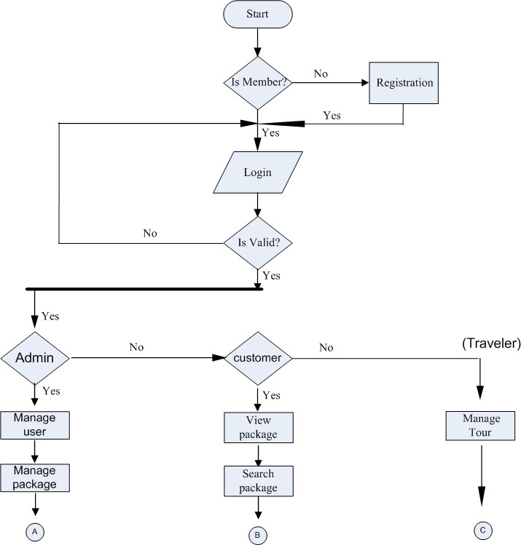**1 LEVEL DFD**

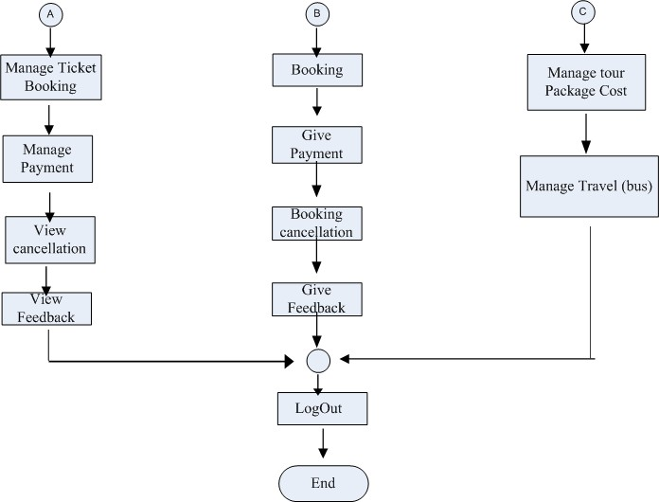

**E-R Diagram:**

**UML Diagram**

**Use case Diagram**

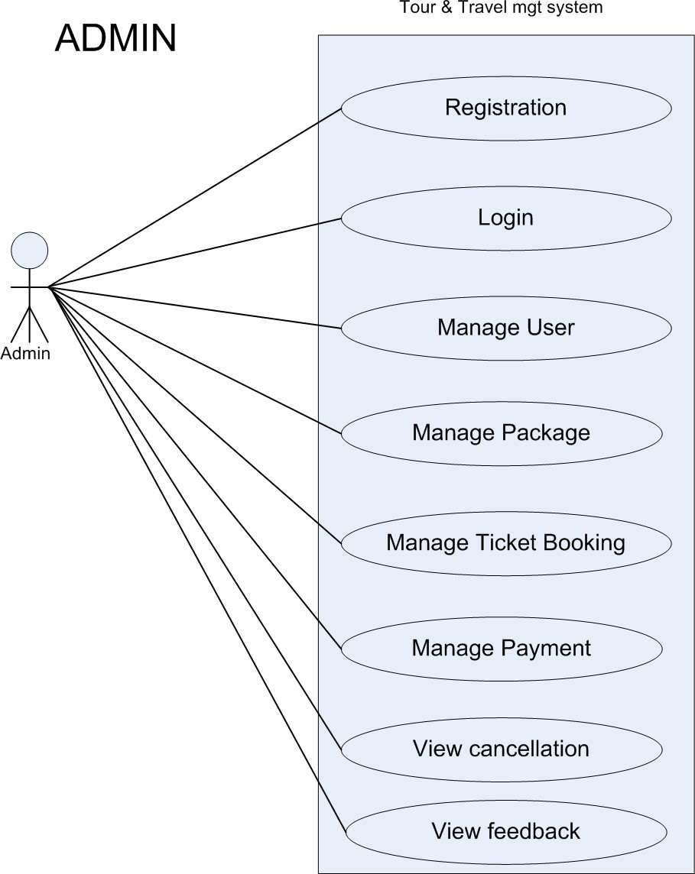

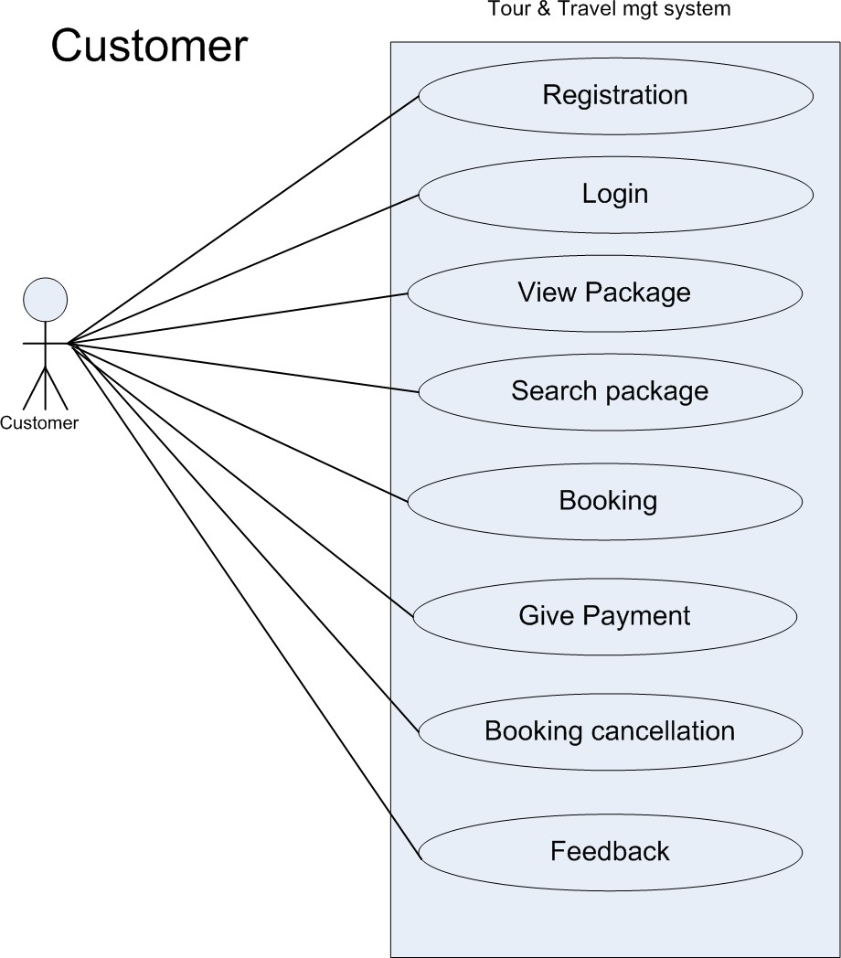

**3 Database Tables**

1. **Table** **Name:** Login_mst

**Description:** To store the admin, customer, Traveler Login Details

**Primary** **Key:** User Name

|  |  |  |  |  |
| --- | --- | --- | --- | --- |
| **Sr.** **no** | **Name** | **DataType** | **Constraint** | **Description** |
| 1 | Username | Varchar(10) | Primary Key | To store the username |
| 2 | Password | Varchar(10) | Not null | To store user type like admin, customer,traveler etc. |

2.**Table** **Name:** AgeRegistration_mst

**Description:** To store Agent Personal Information.

|  |  |  |  |  |
| --- | --- | --- | --- | --- |
| **Sr.**  **no** | **Field** **Name** | **Data** **Type** | **Constraint** | **Description** |
| 1 | Name | Varchar(50) | Not null | To store the Name of agent. |
| 2 | email | Varchar(50) | Primary Key | To store Company Name. |
| 3 | password | Varchar(50) | Not null | To store address. |

**3.Add Destination:** By this admin will add all Destinationname and DestinationID will auto Incremented. DestinationID is primary key.

4. **Package Booking and Payment** : In this schema, BookingID is auto Incremented and primary key. BookingID will Auto Increment and packageId, packageName, packageAmount all will come on the behalf of add package table. UserID, UserName, UserPhoneNumber, UserAddress will fill on the behalf of User_Register Schema.

10

|  |  |  |
| --- | --- | --- |
| **Fields** | **Type** | **Constraint** |
| BookingID |  | Auto Incre.(Primary Key) |
| PackageID | int |  |
| PackageName | nvarchar(max) |  |
| PackageAmount | nvarchar(max) |  |
| UserID | int |  |
| UserName | nvarchar(max) |  |
| UserPhoneNumber | nvarchar(max)) |  |
| UserAddress | nvarchar(max) |  |
| CardNumber | nvarchar(100) |  |
| CVVNumber | nvarchar(3) |  |
| ExpiryDate | nvarchar(max) |  |
| NameOnCard | Nvarchar(max) |  |
| BookingDate | Nvarchar(max) |  |

Table 4.6 Package Booking and Payment

**Destination of Adventure:** Admin will add CityName of Adventure and CityID will auto Increment.

|  |  |  |
| --- | --- | --- |
| **Fields Name** | **Type** | **Constraint** |
| CityID | int | Auto Incre  (Primary Key) |
| CityName | nvarchar(50) |  |

Table 4.11 Destination of Adventure

**Book Adventure and Payment:** Details of booking and details of user will come in this schema.

|  |  |  |
| --- | --- | --- |
| **Fields** | **Type** | **Constraint** |
| BookingID | int | Auto Incre (Primary Key) |
| AdventureID | int |  |
| AdventureName | nvarchar(max) |  |
| Amount | nvarchar(max) |  |
| UserID | int |  |
| UserName | Nvarchar(max) |  |
| UserPhoneNumber | nvarchar(max) |  |
| Address | nvarchar(max) |  |
| CardNumber | int |  |
| cvvnumber | int |  |
| expirydate | nvarchar(max) |  |
| Booking Date | nvarchar(max) |  |

4.User Interface

1.Admin

2.Client

1 Admin Side

1.1 Login

1.2 Admin Dashboard

2 Client Side

2.1 Client Login

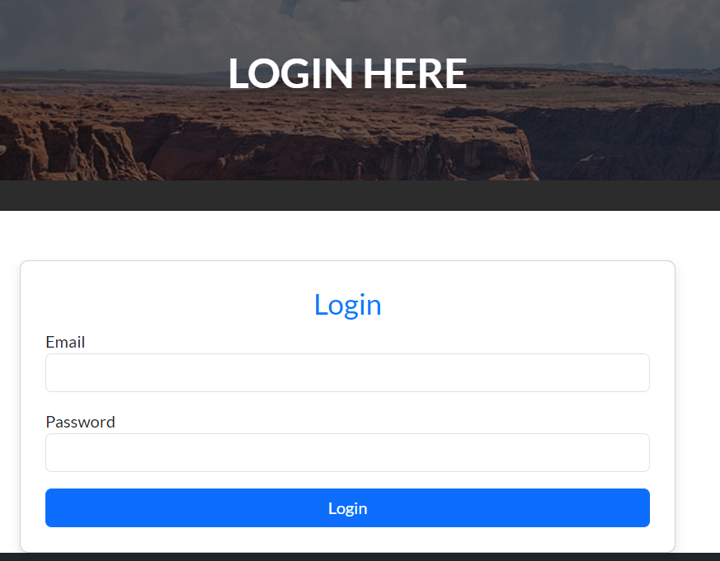

2.2 Client Signup

2.3 Client Home Page

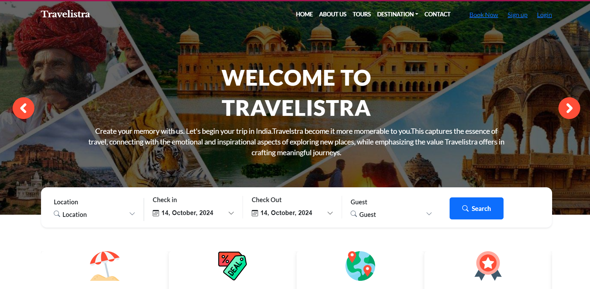

2.4 Tour age

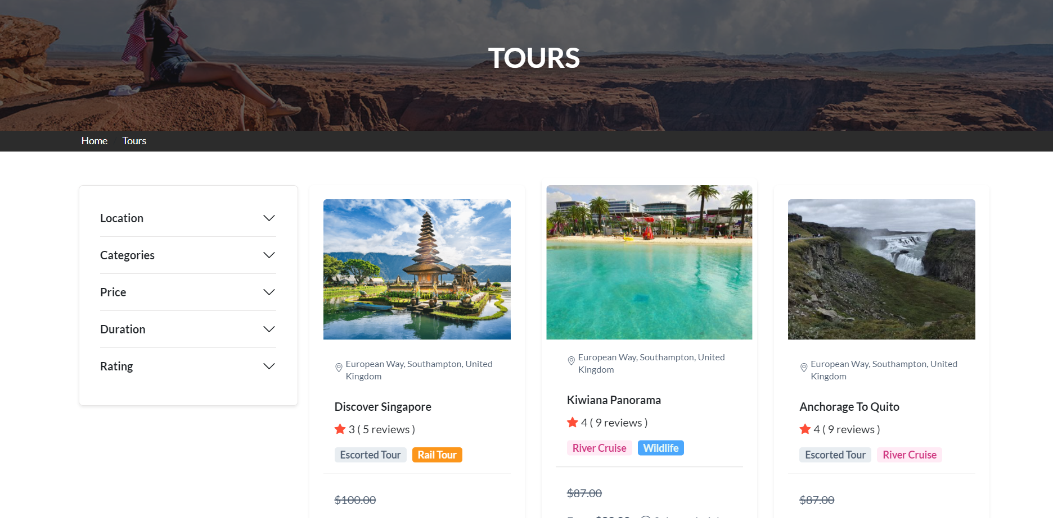

**2.5 Booking Page**

5.Conclusion

Travelistra aims to revolutionize the travel experience by providing a user-friendly platform that simplifies travel planning, booking, and exploration. Through its innovative features like seamless data management, personalized travel recommendations, and real-time updates, Travelistra is set to become a go-to solution for travelers worldwide. With the integration of advanced technology, such as AI and MongoDB for efficient data handling, Travelistra offers a unique and modern approach to the tourism industry, ensuring customer satisfaction and convenience at every step.

As we move forward, our focus will remain on enhancing user experience, expanding services, and constantly innovating to meet the evolving needs of the travel community.

6. Bibliography

1. **Bootstrap Documentation. "Bootstrap: Front-End Framework for Building Responsive Websites." Bootstrap, 2024.** [**https://getbootstrap.com**](https://getbootstrap.com)**.**
2. **W3Schools. "HTML, CSS, and JavaScript Tutorials." W3Schools, 2024.** [**https://www.w3schools.com**](https://www.w3schools.com)**.**
3. **Node.js Documentation. "Node.js for Building Backend Servers." Node.js, 2024.** [**https://nodejs.org**](https://nodejs.org)**.**
4. **Express.js Documentation. "Fast, Unopinionated, and Minimalist Web Framework for Node.js." Express.js, 2024.** [**https://expressjs.com**](https://expressjs.com)**.**
5. **Traveler Trends Report. "2023 Global Travel Trends." Travel Insights, 2023.** [**https://www.travelinsights.com**](https://www.travelinsights.com)**.**
6. **Artificial Intelligence in Travel. "How AI is Shaping the Future of Travel." AI Today, 2024. https://www.aitoday.com/travel-ai.**